Task 1
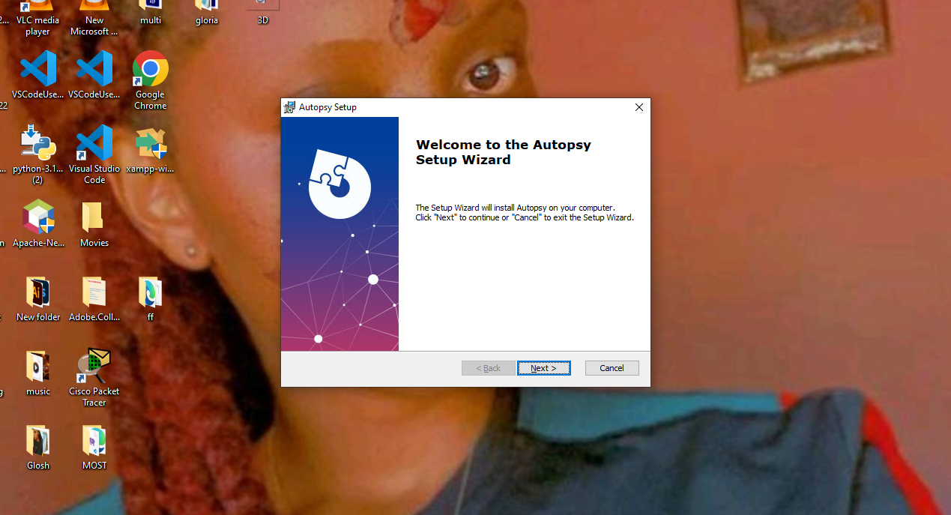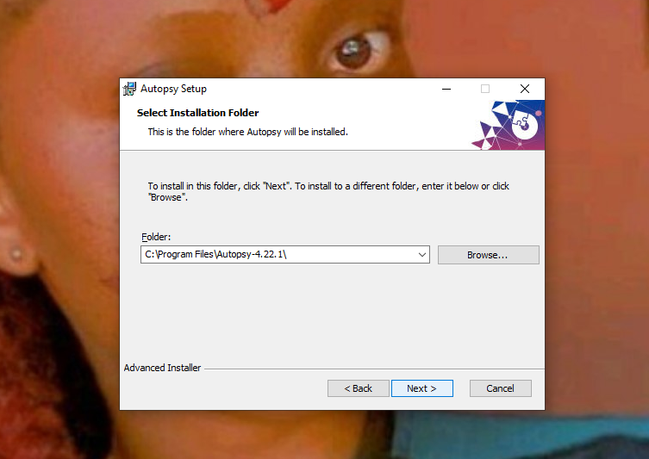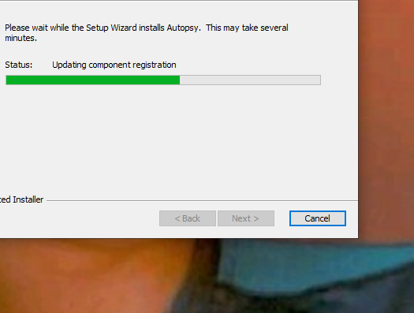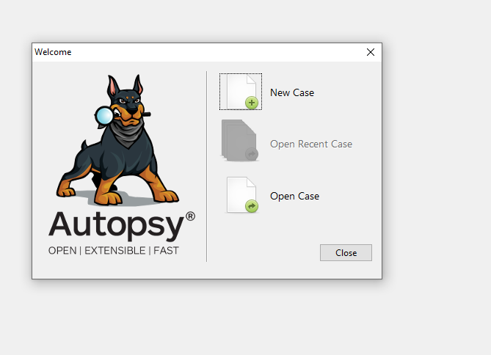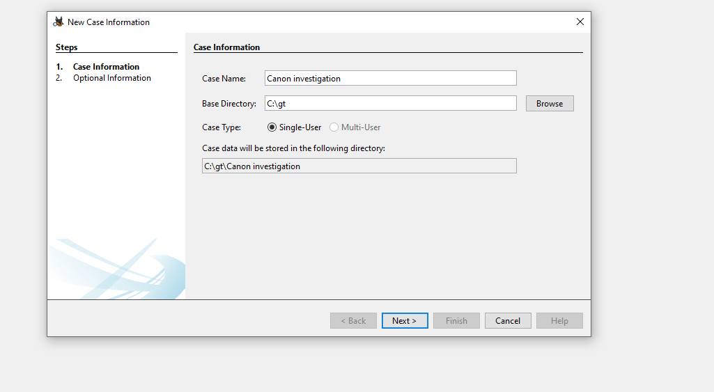

Digital forensics involves investigating crimes using digital devices.
lt involves collecting, analysing and preserving electronic evidence from computers and phones.

Autopsy features.
Case management to organize investigations.
Data investigation to analyse disk images.
File analysis to view file structures.
Key word search to find specific words.
Time line analysis to reconstruct events.
Web Artifacts to analyse browser history.
File recovery to undelete files.
Reporting to generate forensic reports.
Task 2
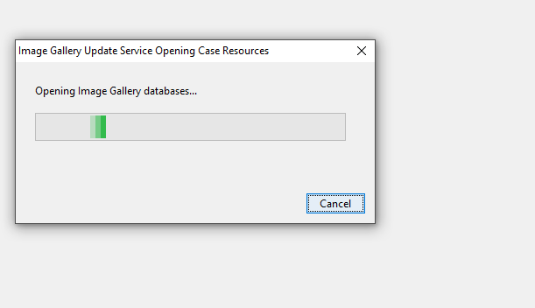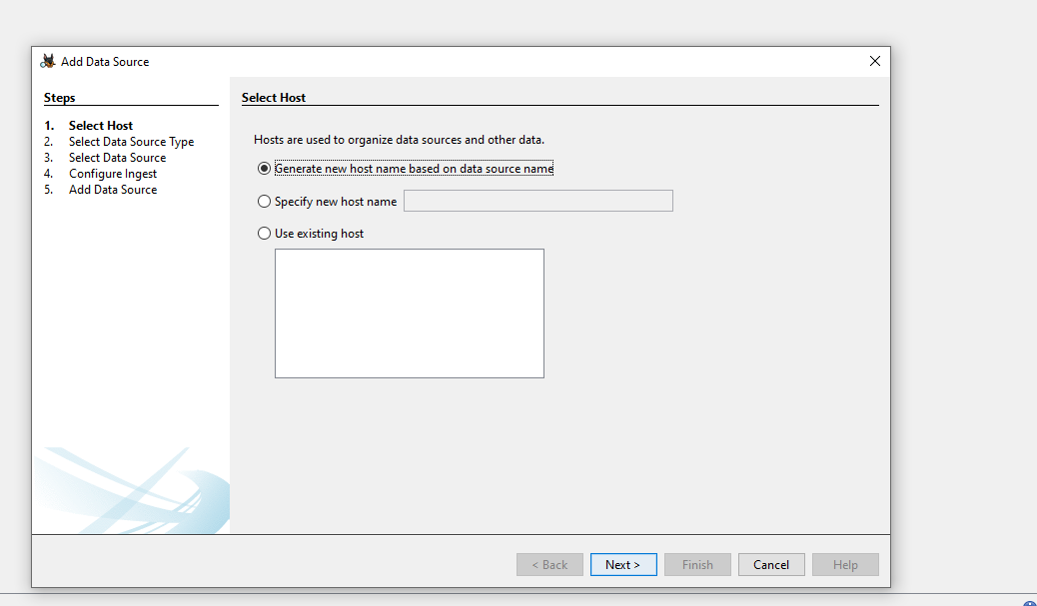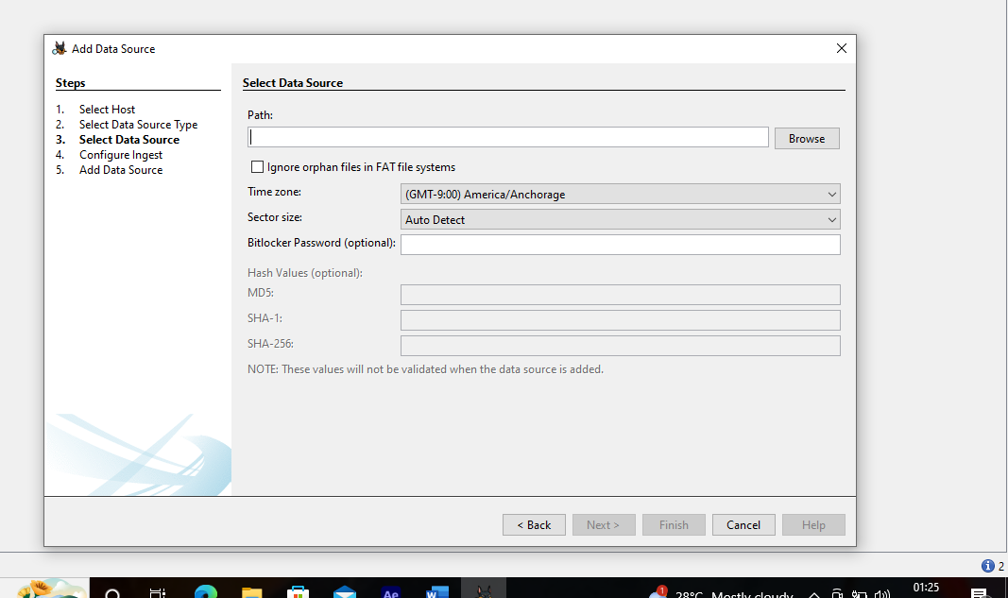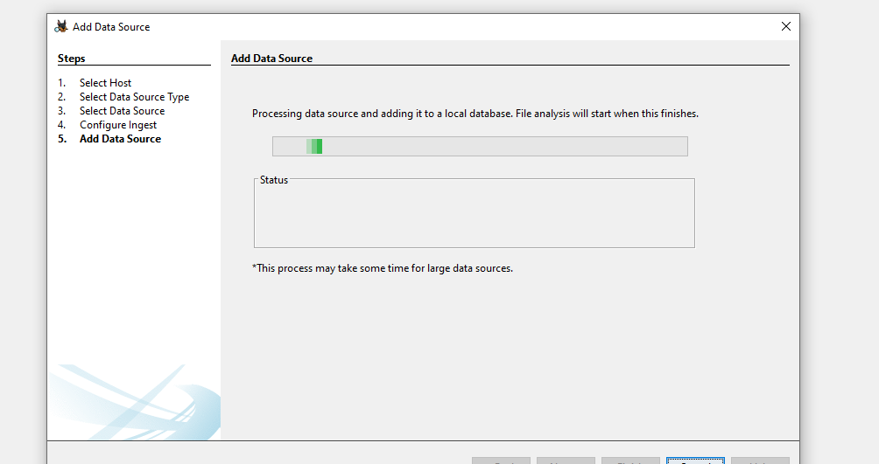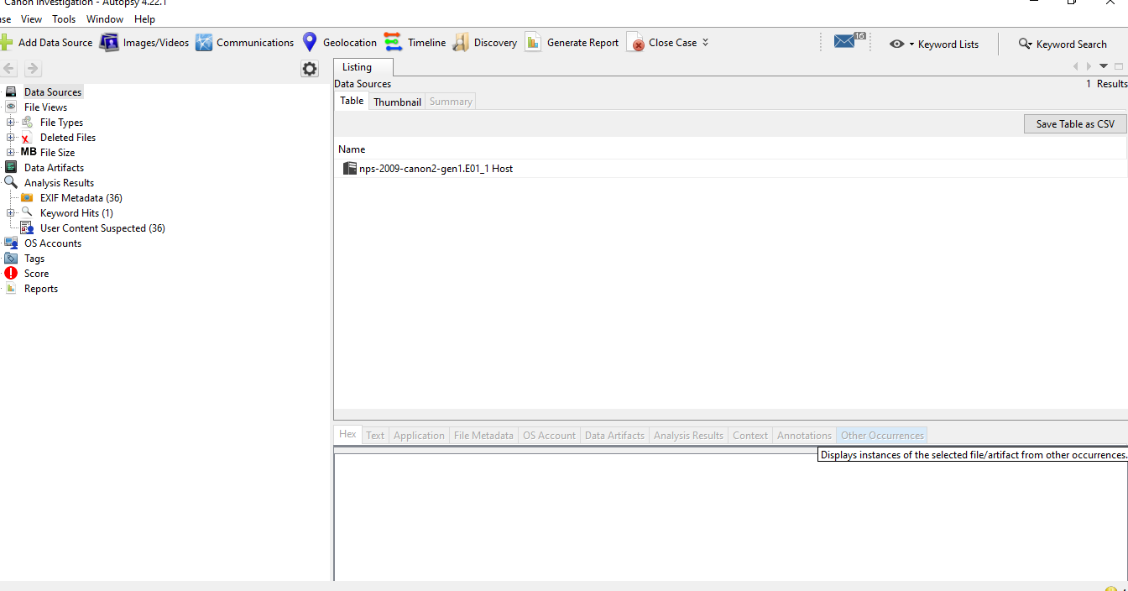

A forensic image is an exact, bit for bit copy of a digital device’s storage.
For example, files, deleted files and metadata.

Task 3
File structures.
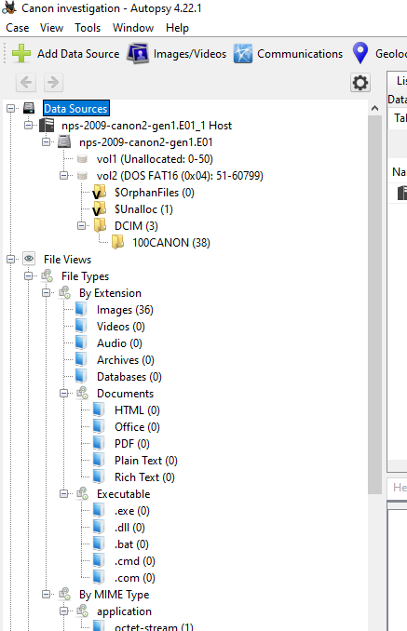

Suspicious files.
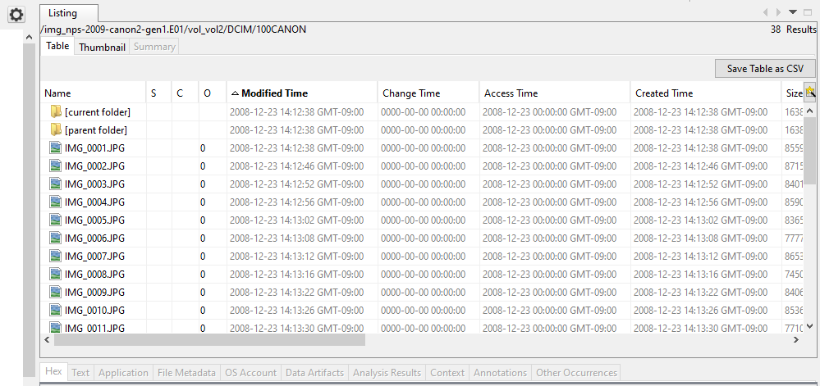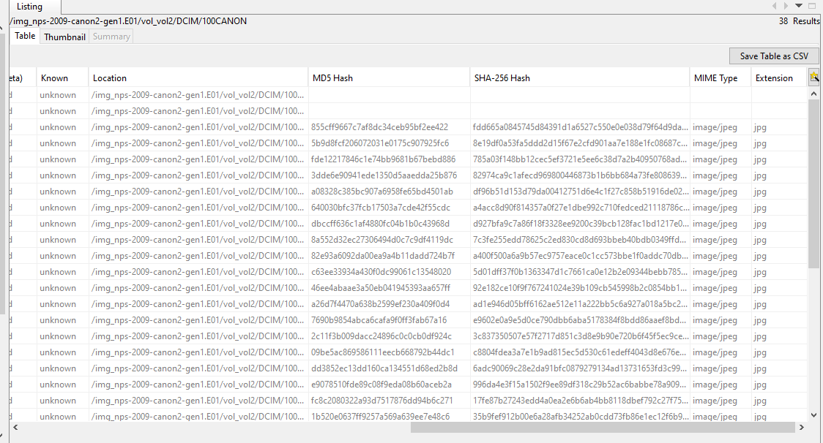

Recently accessed files.
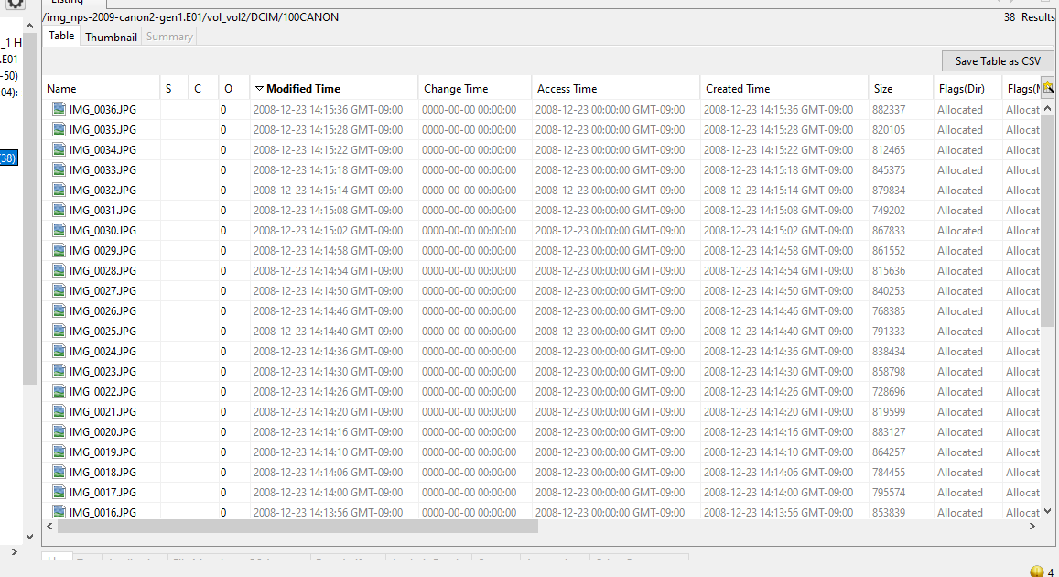

Task 4
Recovery of deleted files.

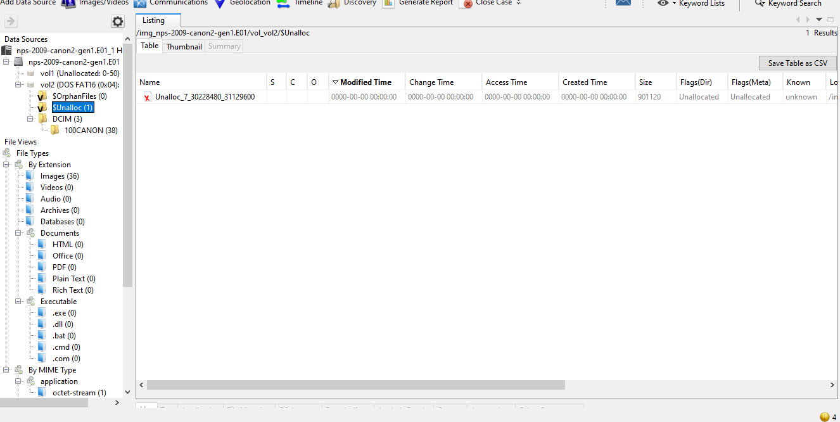
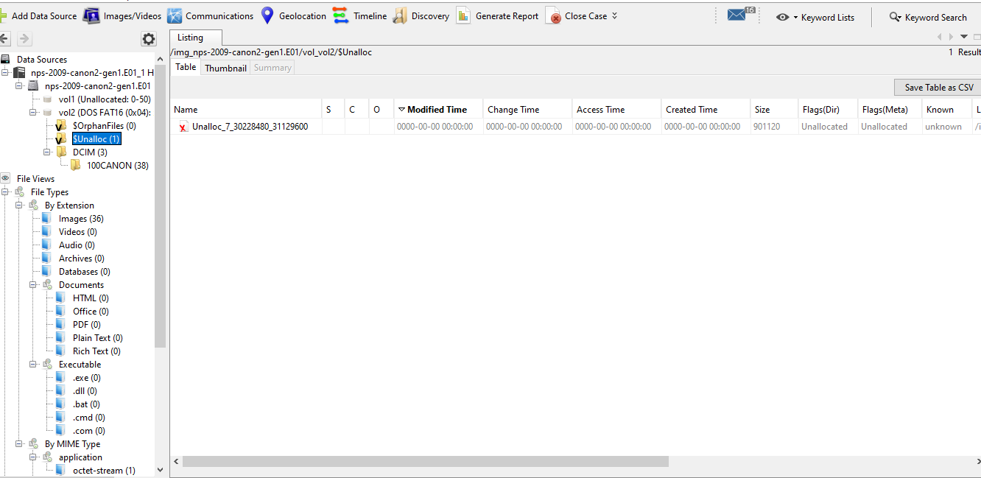

Relevance of recovering deleted files.
Recovering of incriminating files deleted by criminals.
Evidence can be hidden in deleted data.
Helps reconstruct events for example file modifications.

Task 5
As the nps-2009-canon2-gen1.E01 image is from a digital camera, it doesn’t contain any browser history, downloads, or cookies.

Task 6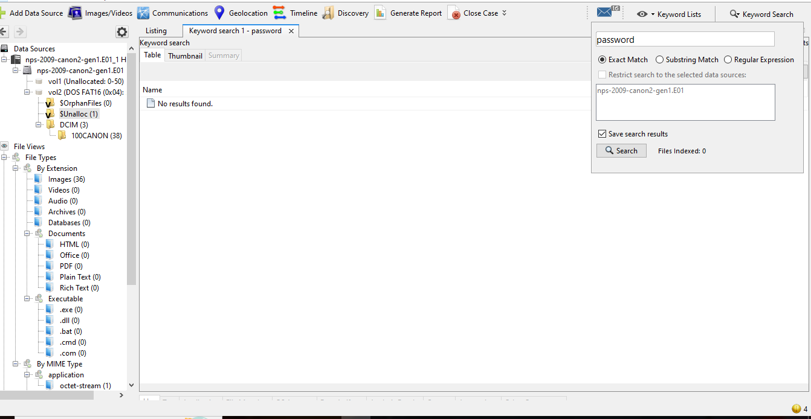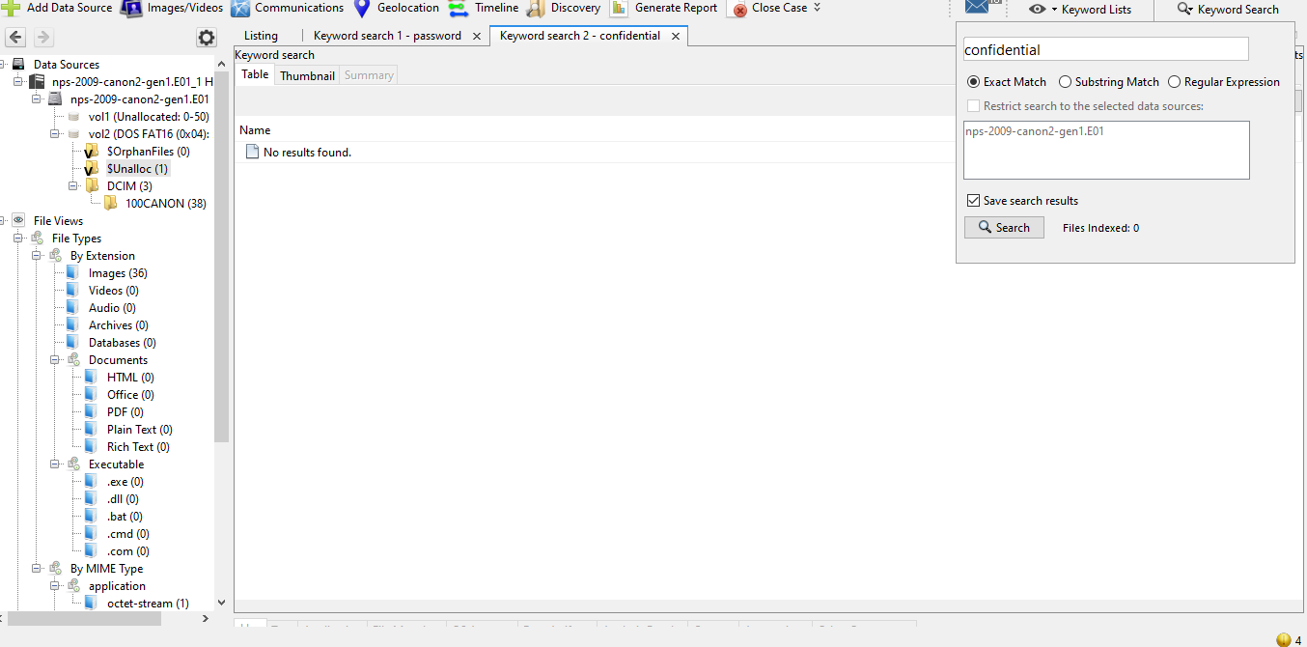
Task 7
Counts view.

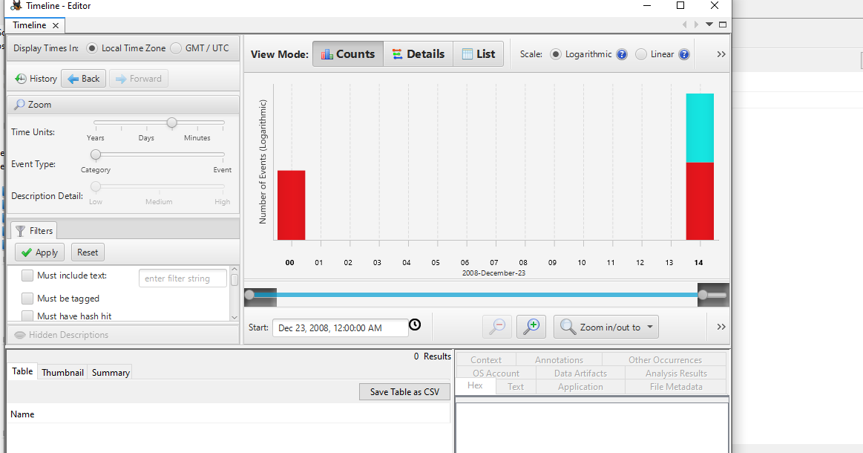

Details view.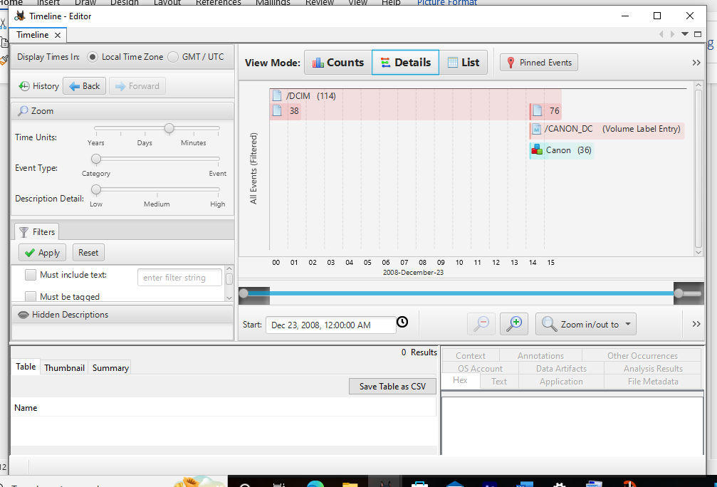

List view
